TECHNICAL DATA SHEET
BULLITT Drain Cleaner Original

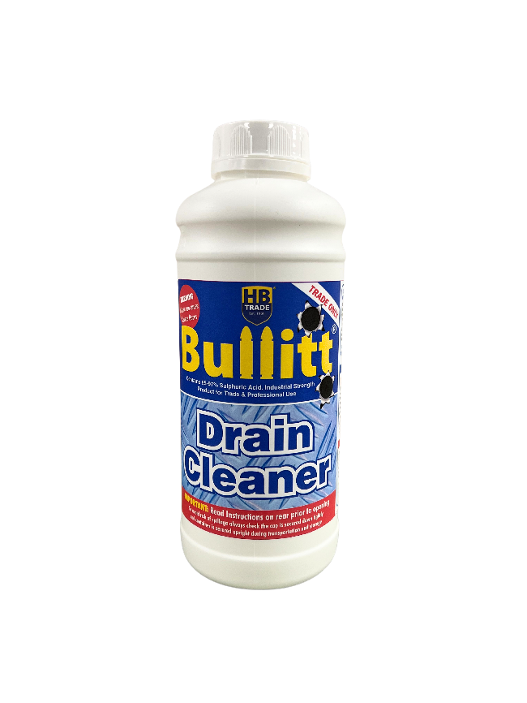
High Strength Sulphuric Acid Drain Cleaner
- 96% Sulphuric Acid Drain Cleaner
- Destroys Organic & Inorganic Compounds
- Works Fast
- Restricted Product

AVAILABILITY: 1L

Unleash the power of Bullitt Drain Cleaner, the most potent acid drain cleaner on the market. With 96% Sulphuric Acid content, it instantly tackles blockages caused by a wide range of organic and inorganic materials.

HB Trade Bullitt Drain Cleaner effectively clears blocked waste pipes and drains filled with organic substances like waste tissues, paper towels, hair, soaps, fats, greases, solidified waxes, leaves, twigs, and other debris that naturally accumulate over time. Its unique formulation, heavier than water, ensures that the active chemical ingredients sink through other liquids to reach the source of the blockage, maintaining their potency even deep within drainage systems.

Important Note: This product is regulated under The Control of Poisons and Explosives Precursors Regulations 2015 and the sale restrictions imposed by the Offensive Weapons Act 2019. Handle with care and follow all safety guidelines.

ACQUISITION, POSSESSION OR USE BY GENERAL PUBLIC IS RESTRICTED.
IT IS AN OFFENCE TO SELL THIS MATERIAL TO A PERSON UNDER THE AGE OF 18 YEARS.
Always read the instructions on the label before using the product.

DIRECTIONS FOR USE:

Preparation: Remove as much water as possible from the sink, drain, or toilet to be treated.
Application: Slowly and directly pour Bullitt Drain Cleaner into the drain over a 10–15-minute period to avoid excessive heat build-up that may damage fittings or pipework.
- Sinks and Small Drains: Use 100–200ml. Allow it to stand for 10 minutes, then flush with water.
- Toilets and Floor Drains: Use 250–500ml per application. Allow it to stand for 10 minutes, then flush with water.
Persistent Blockages: If the blockage persists, seek professional help to disassemble the pipework. Ensure all persons involved are aware of the presence of acid and its health and safety implications.
Preventative Use: Apply a small quantity of Bullitt Drain Cleaner at regular intervals in drains prone to blockage to keep them clear.
.

HANDLING PRECAUTIONS:

READ DIRECTIONS THOROUGHLY BEFORE USE.

Do not mix with bleach, chemicals or other cleaning agents as a violent reaction can occur. Never stand over the drain when applying Bullitt Drain Cleaner. Do not breathe fumes - allow adequate ventilation. Do not use on aluminium, galvanised metal or vitreous enamel. Keep the container’s cap secure at all times. Do not splash onto decorative surfaces as discolouration may occur. A plastic funnel may be helpful, but the other end should be clear of the blockage to prevent blow-back. Under normal circumstances water should never be added to Bulitt Drain Cleaner. A small spillage (i.e. up to one container full) may be flushed down the drain with excess water as the heat generated will be dissipated effectively over the large surface area. Wear suitable chemical resistant protective equipment: gloves, goggles, overalls etc. If unsure contact Hilton Banks Limited. In a large (over 1 litre) spillage situation contain it with a solid absorbent - e.g. sand: and contact an authorised waste disposal company.

Tel: 01282 831251

HC0517 13/04/21 V1.1

